Instructor: John Beswetherick
Course: BUSIT 202
From: Christopher Singleton
Subject: Assignment5 – More Dimensional Modeling Techniques
Date: 02/09/2016

COVER MEMO

Junk dimension are probably one of the most complicated and harder layouts in understanding, because the attributes don’t belong in any fact table or other dimension tables. Junk attributes are indicator attributes and flags that have unique, discrete values that would otherwise be overwhelming in a fact table or even if you add them to their own dimension tables, but instead of doing such, you add them to a table with other attributes that don’t really have any logical place of their own.

The other type of scenario that I chose is a role playing dimension that has a lot to do in satisfying a structured business need that can be referenced multiple times in a fact table with each reference providing a distinct logical role. Reference attributes are good at processing multiple continuing operations of the same type throughout the network of tables. In other words, the typical attributes in role playing would have something to do with an ISBN number or catalogue number that is used with the same product in being purchased over and over again. Role playing with date dimensions can also typically include [Date Of Sale], [Date Of Delivery] and/or even [Date Of Hire].

Junk Dimension
As explained earlier, junk dimensions are dimensional attributes that don’t have any logical placement in a fact table or other existing dimension tables. Junk dimensions are typically flags and/or indicators (yes/no) that would otherwise clog up the fact table or also have no logical sense in any other dimension table, so we place them in a junk dimension table, which helps in reducing complications and keeps everything else in a logical order. Here I am showing an example of a normal relationship with a junk dimension and fact table. Notice you have more descriptive attributes in the [Dim Order Indicator Junk] table and two measures in the fact table that are used to slice and dice for analytical processing. This meets the criteria for the business needs, because you reduce the size of the [Fact Retail Sales Orders] table and organize a group of attributes that would not be considered normally in any other table.

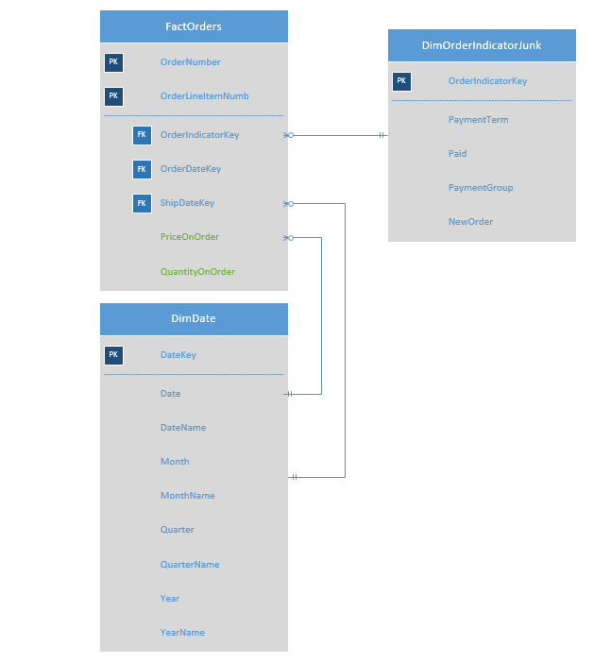

The [Dim Order Indicator Junk] table attributes are noted as bit datatypes (Yes/No).

Junk Dimension Table
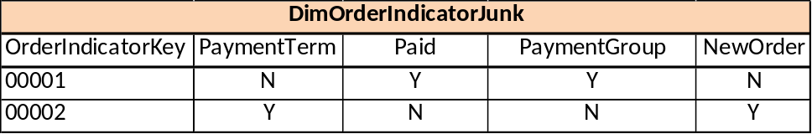

Date Dimension Table
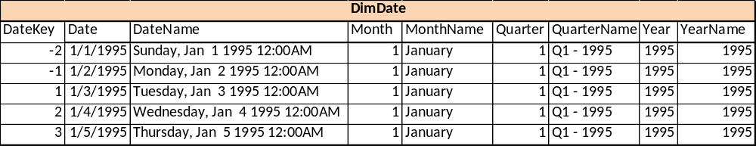
Fact table
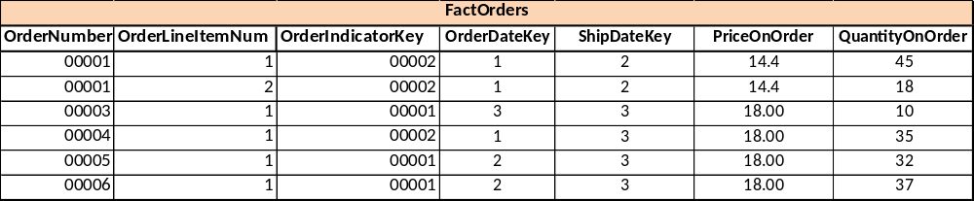

Role Playing Dimension
Role playing dimensions have to do with attributes that are used over and over again (recycled). These dimensions are vital in creating multiple same type transactions that are continuous ongoing business day to day operations. I’m simulating here in selling coffee at an internet coffee store in making my point. The ISBN number and coffee name is being recycled according to how many types of coffee are being sold directly from the internet. In this scaled down version, this satisfies a business criteria that places the attributes that are continuously recycled (used over and over again) in a dimension table that make’s sense in keeping the logical format of the database. Please note that an ISBN number can be called many other things (catalogue, skew) and that this is another indication that it is a role playing dimension.

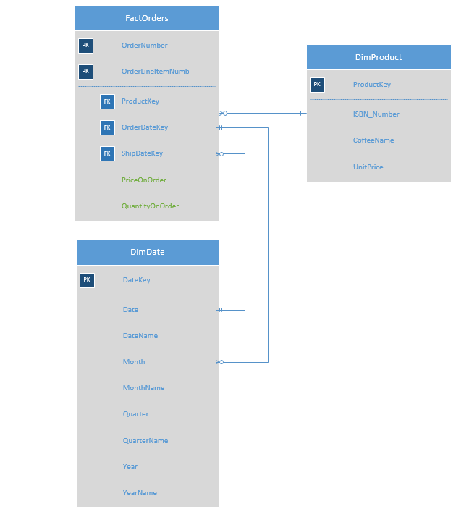

Product Dimension Table
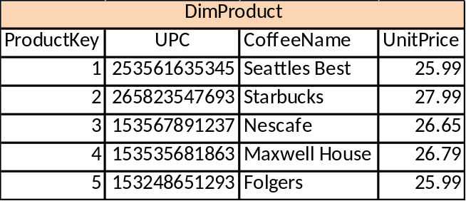

Date Dimension Table

Fact Table
